Male Loneliness Gaming Script
~1,732 words · ~12 min runtime
Edit this document in Word, then sync: python bin/build_visual_script.py SCRIPT.md --sync-docx visual_script.docx

HOOK
[VO] October 2019. Washington, D.C.
[SHOW: conference room / Men's Health Network panel — archival or title card]
🎨 CUSTOM

[VO] Men's Health Network brought together psychiatrists, public health researchers, and patient advocates for one question: why are depression and anxiety in American men being missed — and why are male suicides still climbing?
[SHOW: stat card — "Male suicide rates up ~20%" — source: Men's Health Network / PCORI Expert Panel Report, Oct 2019]
🔍 GENERAL
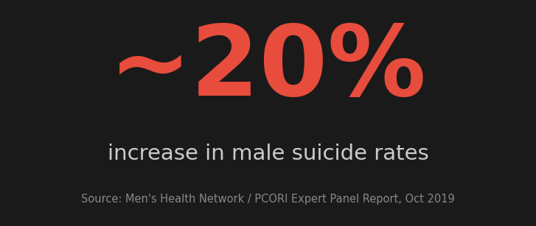

[VO] The summary report from that meeting put it bluntly: the rate of male suicide had gone up by roughly twenty percent, and millions of men still had no emotional vocabulary to describe what they were feeling. Because the stigma was still treating loneliness and depression as a weakness rather than an illness — and men had no real channels for seeking help without it costing them something.
[SHOW: data card — "Men with zero close friends: 3% (1990) → 15% (2021)" — Survey Center on American Life, AEI (May 2021) — aei.org/articles/mens-social-circles-are-shrinking]
🎨 CUSTOM
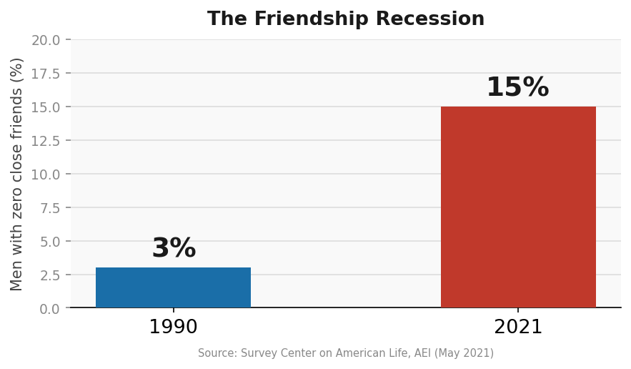

[VO] This had been building long before that panel. In 1990, three in every hundred men reported having no close friends at all. By 2021, that had climbed to fifteen in every hundred — five times higher. And over that same thirty years, the share of men with six or more close friends had been cut in half. Researchers consistently find that men with no close confidants are significantly more likely to experience depression, anxiety, and suicidal ideation. The friendship recession is not just a social problem — it is a health one.
So why hasn’t this become a bigger societal conversation? Suicide rates are climbing and researchers are publishing the data, but men are still not talking about it. Is it because admitting you are struggling still comes with a social cost — that asking for help reads as weakness? And if that cost is real, why is nobody addressing it? Are we still treating loneliness and depression in men as a personal failure rather than a health problem? Do men actually need permission to admit that they need help?
Most men have no idea how many others are in exactly the same position.
[SHOW: world map — loneliness rates by country — Meta-Gallup Global State of Social Connections (2023) — gallup.com/analytics/509675 — highlight: 19-29 year olds are the loneliest age group globally at 27%]
🔍 GENERAL

[VO] A global survey across 142 countries found roughly one in four adults felt lonely, with young adults aged nineteen to twenty-nine reporting the highest rates of any age group worldwide. COVID arrived on top of a loneliness problem that had already been growing for a generation. Lockdowns closed pubs, sports clubs, mosques, and community centres all at once, in every country that imposed restrictions. These were the places where men had been quietly keeping their last few connections alive, and overnight they were gone with nothing to replace them.
[SHOW: WHO / global headlines on social connection — 2023–2025 montage]
🔍 GENERAL

[VO] The World Health Organization eventually put loneliness on the same level as smoking — not as a metaphor, but as an actual measured risk to how long you live. In country after country, researchers were flagging the same pattern: men were losing close friendships faster than women, and were far less likely to ask for help.
[SHOW: gaming montage — Discord, squad chat, Minecraft, sports sim leagues]
🔍 GENERAL

[VO] Around the same time, gaming was growing. Hundreds of millions of men were spending more time in online games than ever before. The WHO added gaming disorder to its diagnostic manual in 2018, and researchers and headlines were treating it as part of the problem — that men were retreating into virtual worlds rather than dealing with what they had lost. But researchers who actually tracked real gaming communities found something more complicated — for some men, online games were one of the few places left where they were still learning to connect.
[SHOW: Abdullah on camera]
🎥 SELF

[TH] 🎥 SELF
I am Abdullah Hassan. And this is the male loneliness epidemic: the digital third place.
---
SECTION 1 — WHERE THE CONNECTIONS WENT
[SHOW: archival — pub, five-a-side football, men at a bar watching sport]
📽 ARCHIVE

[VO] For most of the twentieth century, men had structures around them that kept them connected without having to think about it. There is an idea in sociology called a third place. Your first place is home. Your second place is work. The third place is everything else — the pub, the sports team, the church, the union hall. The place where you show up without a specific reason and end up around people anyway. For most of the twentieth century, men had those.
[SHOW: graph or simple card — "Men's close friendships declining over 20 years" — cite Prochnow/TAMU]
🔍 GENERAL

[VO] Research over the last twenty years shows those bonds thinning. Men report fewer close friends and weaker friendships than they had a generation ago. And because many were raised on the idea that a real man should be strong, silent, and self-sufficient, when the loneliness hits they do not name it. They drink, scroll, withdraw, or disappear.
[SHOW: timeline — 2019 panel → 2020 lockdowns highlighted]
🔍 GENERAL

[VO] Researchers were already raising the alarm by 2019. When COVID closed what was left of those spaces, men who had been quietly managing with one or two connections were left with none. The crisis had been building for thirty years — by 2023, the Surgeon General of the United States had named loneliness a public health epidemic.
---
SECTION 2 — THE CASE AGAINST GAMING
[SHOW: news montage — "video games cause violence", screen addiction, basement gamer stereotype]
📽 ARCHIVE

[VO] If you grew up in the 2000s or 2010s, you heard one story about games and men: screens were making men more isolated and pulling them away from real relationships.
[SHOW: DSM-5 "Internet Gaming Disorder" graphic — conditions for further study]
🎨 CUSTOM

[VO] American psychiatrists were taking it seriously enough to formally study it — looking at men who could not stop playing even when it was damaging their lives, who had withdrawn from offline relationships, and who reached for a game every time their mood dipped.
[SHOW: data card — "High-risk gamers: depression 9.5%, anxiety 14.5% — Low-risk gamers: depression 4.5%, anxiety 9.1%" — Jung et al., Psychiatry Investigation 2025 — doi.org/10.30773/pi.2023.0385]
🎨 CUSTOM
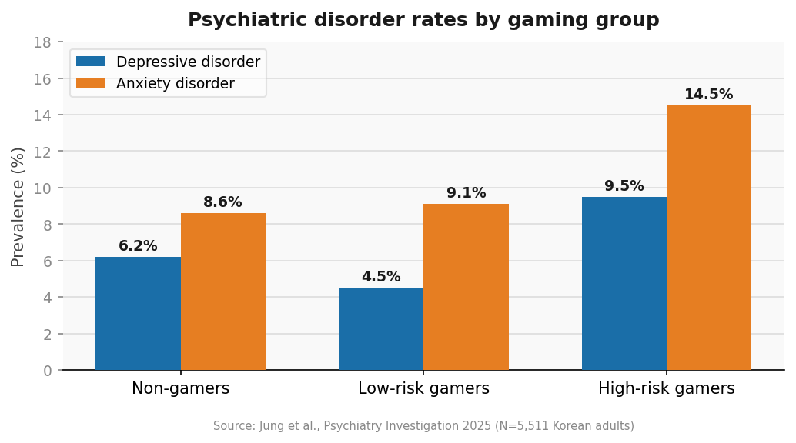

[VO] A nationwide survey of over five thousand Korean adults found that men gaming compulsively reported more than double the rate of depression of moderate gamers, and roughly sixty percent higher rates of anxiety. The worry was that men were replacing real friendships with avatars, and then finding offline conversation even harder when they finally logged off.
[SHOW: split card — "Illusion of socialising" / hours online, isolation up]
🔍 GENERAL

[VO] Some men were using games to feel surrounded by people without the risk of actually being known by any of them. And for men already severely depressed or using games only to numb out, online play becomes another form of avoidance rather than a path toward connection.
---
SECTION 3 — WHAT THE RESEARCH ACTUALLY SHOWS
[SHOW: Tyler Prochnow / Texas A&M headline — digital third place]
🔍 GENERAL

[VO] When researchers actually looked at what was happening inside gaming communities, the picture was more complicated than the headlines suggested.
A public health researcher at Texas A&M named Tyler Prochnow decided to study one specific community — an online football simulation league. He followed it for a year. And the question he asked was simple: who are you actually talking to in here, and what are you talking about?
[SHOW: chat log aesthetic — game talk morphing into real-life topics]
🔍 GENERAL

[VO] It started with tactics and roster moves, but over time the conversations shifted to stress, anxiety, and things happening in their actual lives. One member asked another for advice on adoption because he knew that person had been through it. The game was the reason they were all in the same room. What they ended up talking about once they were there was something else entirely.
[SHOW: data card — ONE GRAPH: Korean nationwide study — low-risk gamers vs non-gamers vs high-risk gamers on loneliness scores]
🎨 CUSTOM
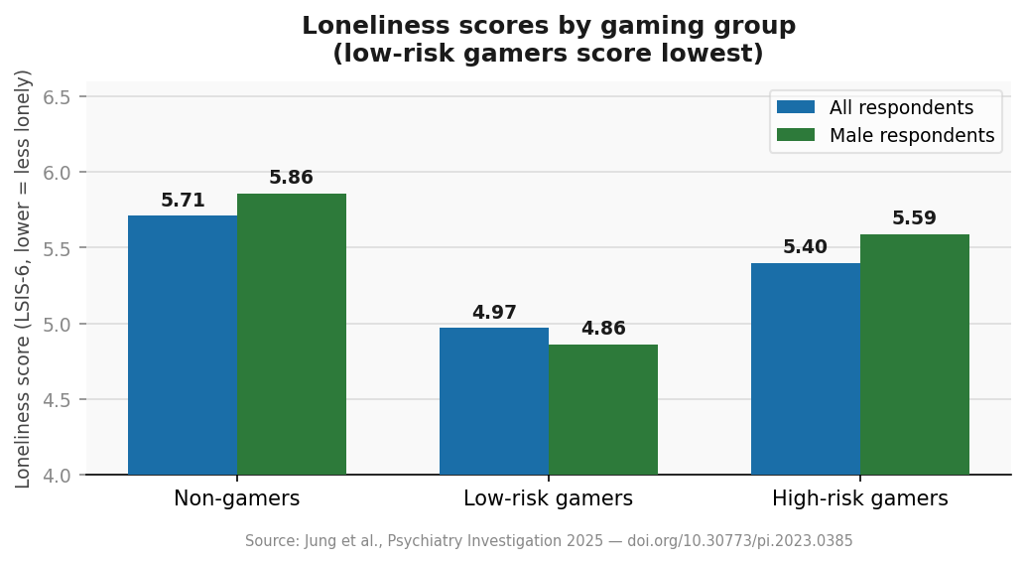

[VO] Prochnow found that members with more depressive symptoms and less real-world support were about forty percent more likely to form and keep ties inside the community than members who already had strong offline networks.
A nationwide study in South Korea points in the same direction. When researchers split adults into non-gamers, low-risk gamers, and high-risk gamers, low-risk male gamers reported lower loneliness than non-gamers or high-risk gamers. The benefit was not automatic — it showed up when play stayed moderate and the community was doing real social work, not when gaming became compulsive escape.
[SHOW: Discord / squad comms / cross-generational gaming — Minecraft, co-op]
🔍 GENERAL

[VO] That matches what sociologists call a digital third place — the pub or the five-a-side pitch, rebuilt online. The shared goal lowers the pressure enough that men start talking about things they would never raise at work. Guilds, clans, and long-running servers become informal support networks where older and younger players end up mentoring each other across an age gap that barely exists offline anymore.
---
SECTION 4 — WHAT GAMING CANNOT DO
[SHOW: Abdullah on camera]
🎥 SELF

[TH] 🎥 SELF
Real quick — if this is useful, subscribe. It genuinely helps the channel.
[SHOW: split card — low depressive symptoms + moderate play vs high-risk / clinical depression]
🔍 GENERAL

[VO] Gaming is not a substitute for real relationships, and it is not clinical care.
For men at high risk — severe depression, suicidal thinking, using games only to avoid the world — the answer is still professional help, not a Discord server. The Korean data also shows that when gaming tips into high-risk compulsive use, the loneliness benefits disappear.
The evidence is strongest for a narrower group: men with lower depressive scores who are looking for connection, playing in moderation, and embedded in communities that talk about real life — not just rank. For them, gaming can reduce loneliness, help them practise vulnerability, and sometimes build the confidence to seek advice offline.
[SHOW: stepping-stone graphic — online clan → local meetup / therapy referral]
🎨 CUSTOM

[VO] The research points toward gaming as a stepping stone rather than a destination — shared competition that breaks down the strong-and-silent barrier, digital friendships that reinforce healthier behaviour, and communities that can point someone toward real-world support once the conversation gets serious enough to need it.
---
CLOSE
[SHOW: empty third place → active gaming community → men laughing in voice chat]
🔍 GENERAL

[VO] The male loneliness epidemic was years in the making. The pubs closed, the teams disbanded, and the friendships quietly thinned out — while men were still being told that struggling was not something you admitted out loud. Screens took the blame, and for men gaming compulsively to escape the world, some of that holds. But the research also points somewhere most people miss: for millions of men, online communities have become one of the only spaces left where they are still finding each other, still talking about real things, and sometimes finding their way toward support they would never have sought on their own.
[SHOW: quote card — Surgeon General advisory on loneliness, 2023 — white on black]
🎨 CUSTOM
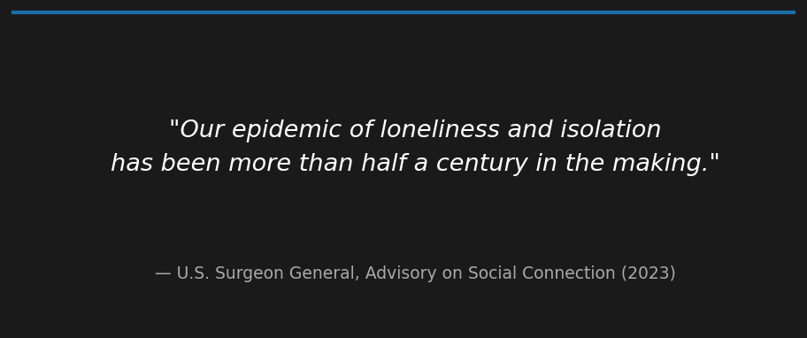

[VO] In 2023, the U.S. Surgeon General called it what it is:
[SHOW: quote — white on black, no music]
🔍 GENERAL

""Our epidemic of loneliness and isolation has been more than half a century in the making.""
[PAUSE]
[VO] Half a century. And for most of that time, men were expected to manage it quietly and alone.
That starts to shift when men start talking — not just in therapy, though that matters, but in the everyday spaces where they already spend time. A gaming server. A group chat. A comment section. Anywhere the conversation can actually start.
So here is what I want to ask you directly: where have you found that? A community, a person, a space where you actually felt less alone — tell me in the comments. And if you are still looking, say that too. The data is clear that most men have no idea how many others are in exactly the same position. The silence is the problem. Every honest conversation is part of the fix.
And if someone in your life is struggling — the simplest thing you can do is ask them directly how they are doing, and actually wait for the answer.
[SHOW: Abdullah on camera]
🎥 SELF

[TH] 🎥 SELF
Thank you for watching. If this video made you think differently about loneliness, gaming, or men's mental health — drop a comment, share it with someone who needs it, and subscribe if you want more. I will see you in the next one.
---

